About Seta

One of the leading software consulting outsourcing companies in Vietnam, SETA International has a proven track record of delivering robust software solutions to organizations worldwide. Seta offers a Hybrid Business Model – onshore and offshore managed IT services - that changes with scale and flexibility depending on the scope of the project.

Ranked as a top 10 leading IT Outsourcing company in Vietnam, Seta International has more than 500 clients around the world in industries such as retail, travel, restaurant, medical, manufacturing, government, gaming, insurance, entertainment, and more.

Challenge

SETA International was developing a soccer engine that could detect events in soccer matches, analyze the matches, and create highlight videos, a very common task that has to be done frequently.

The engine focused on six key events: Goal, Attack Left, Attack right, Card, Corner kick, Replay Attack. To train the deep learning model, a dataset of 800 full-match soccer videos from seven popular leagues: Worldcup, Champion league, La Liga, Bundesliga, Seria, League one, Premier league ... was prepared.

Approximately 4000+ samples per label, on average, were provided for the SSport dataset. BlueEye was the platform of choice for Seta International to label such a large dataset. Not only was a Data Labeling Platform provided, but BlueEye also worked closely with Seta International throughout the data labeling process.

Our solution (business)

Not only did we provide our on-premise version of our labeling platform to Seta, with many specialized customizations to support Seta AI Engine, but BlueEye also collaborated with Seta on labeling more than 1200 hours of soccer videos. Our three teams consisted of more than 40 well-trained data labelers on each team, working day and night, in different time zones to support this project.

Managing and ensuring the quality of such a large workforce was no easy task. Thanks to BlueEye’s easy to use, advanced project management features, AI assisted smart tools that help to auto-label and many other advanced tools, we were able to complete the project within one month and greatly appreciate Seta International for their trust and recognition on our solution.

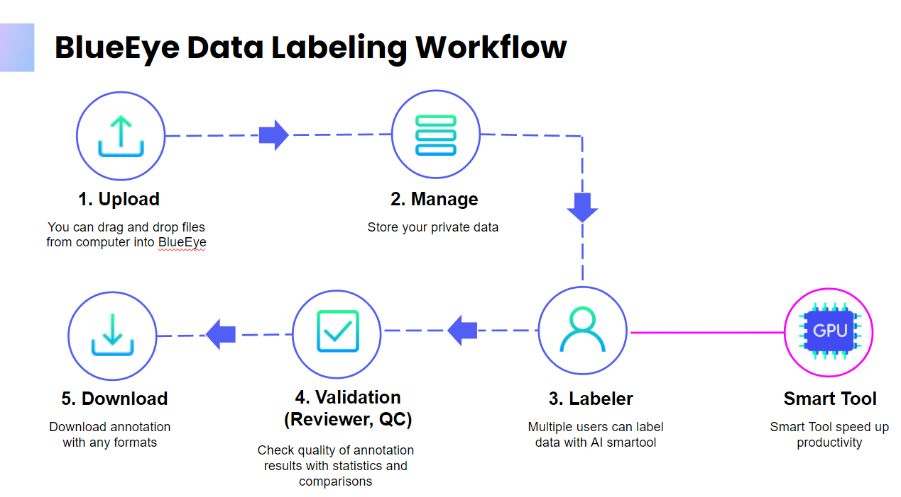

Our solution (Technical)

With the use of advanced, modern technologies, including React JS (with React Hooks, Redux) for front-end development, and NodeJs, Golang, and Python for back-end development, our annotation platform can reach and remain at high performance while being used by multiple labelers concurrently, which is one of the key factors leading to the success of SETA’s project.

The labelers had to annotate on long soccer videos, which is laborious and error-prone. Our unique real-time collaboration feature helped the labelers annotate the videos together, which increased the labeling speed as well as to detect and correct others' issues on time, ensuring the quality. The feature was built on top of WebSocket, with careful system architecture design and highly optimized code, which allowed us to deliver the final dataset to Seta-International on time.

Below is the high-level architecture of the BlueEye system that we deployed on the AWS cloud.

